Dear Friends
With apologies to John Keats, ‘The season of mists and mellow fruitfulness’ is upon us.
The harvest festivals at our churches were a little different this year. Thank you to everyone who brought foods that were donated to the food bank at Littlehampton. Gail has written about the trip to Littlehampton below.
Harvest
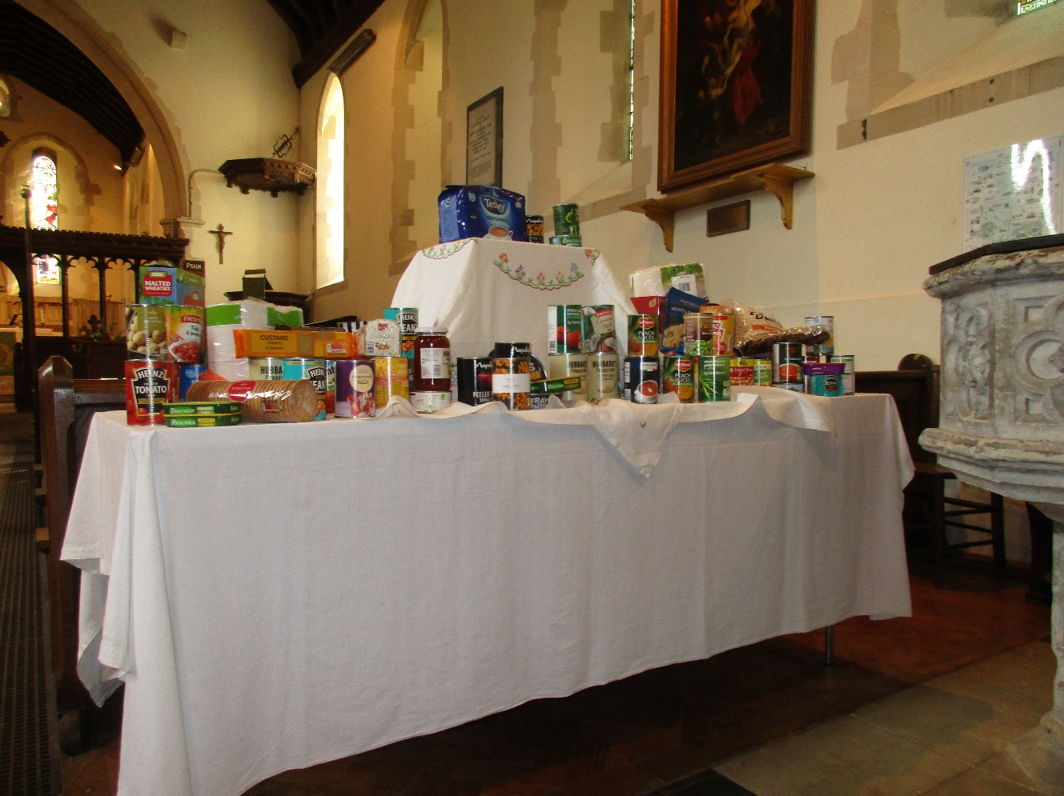
The picture is of harvest donations displayed at Patching. The donations at Clapham church were equally generous but unfortunately we didn’t get a photograph. All together there were 20 carrier bags of tins and 2 large boxes of glass and soft packaged goods.
HARVEST CELEBRATIONS AT CLAPHAM AND PATCHING 2020
Due to Covid 19, it was decided that our usual annual Auction of Harvest goods would not be safe. Therefore, we thought that collecting dry goods for the Littlehampton Food Bank would be a good option and, also, that we could have two Harvest Services, one at Patching and one at Clapham.
Peoples’ generosity was outstanding with many donations from non Church goers too - thank you all!
As Kath already had half a car-load from Patching, we added Clapham’s donations making for a very large car- full of tins, jars and packets to be delivered to the Baptist Church in Littlehampton.
Masks on, Kath and I set off- what a drive! There are more potholes than road it seems in some places and the rattle of tins and swoosh of packets as we bumped our way along meant slow and careful driving.
However, we arrived safely with all goods intact to be met by a gentleman with a trolley so transferring the bags and boxes was not as painful as it might have been.
The journey back was significantly quicker!
Gail
Time of change at Clapham
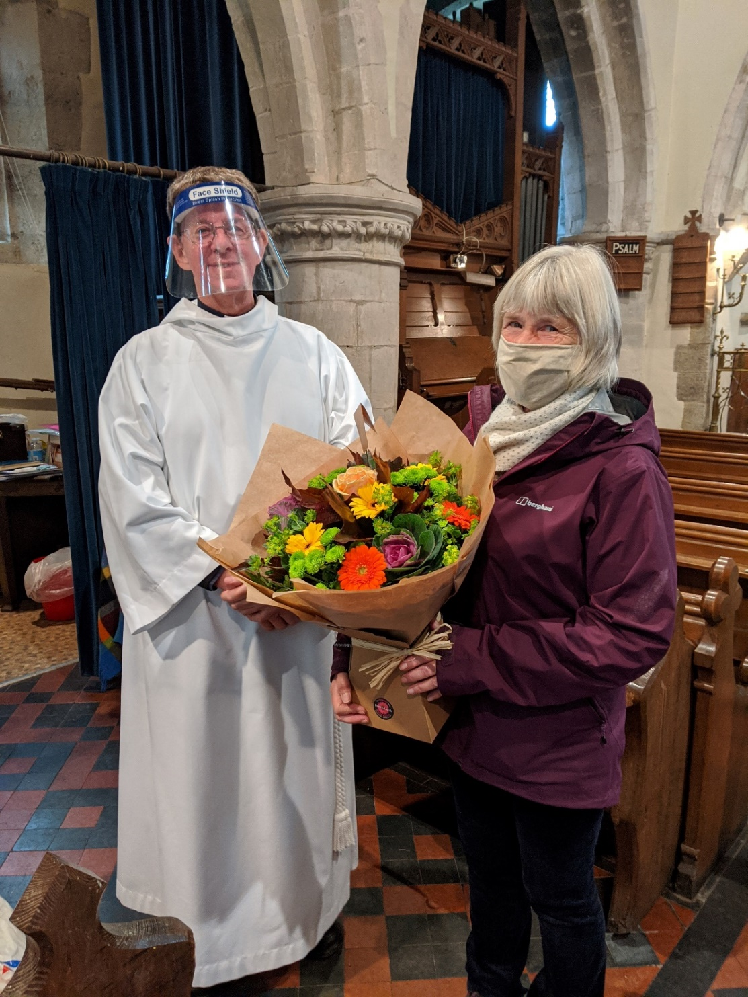
Revd Colin Cox who made the presentation and Gail
After 7 years, Gail is stepping down from the role of churchwarden at Clapham. The role is now shared by Maggie Somerset and Sian Fletcher. After the harvest service Gail was presented with a bouquet in appreciation of her excellent stewardship during her years in the role. Thank you Gail for all your hard work.
AGM Reminder
The Annual General Meeting on Sunday 15th November, 2.30pm and will be conducted via zoom. Details on joining the AGM will sent nearer the time. There are vacancies on the committee. If you would like to nominate an officer or committee member please contact Kath Tel: 01903 871147, Email: hutchinson997@btinternet.com
Legacy
We are honoured to receive a legacy from the estate of Dr Paul Martin who died in April this year.
He and his wife who died some years earlier, had both been eminent medical practitioners. They spent their retirement years in Clapham where they contributed to church and community life.

