Friends
You may have heard that our president Revd. Helena Buqué has officially, become the incumbent for Findon, Clapham and Patching after 5 years as priest in charge.
Congratulations Helena and welcome to your newly confirmed position.
The licencing took place at Findon church on 5th May with only Helena and Archdeacon Luke Irvine-Capel present. This is an occasion to be celebrated but the celebrations need to wait until current restrictions are sufficiently eased.

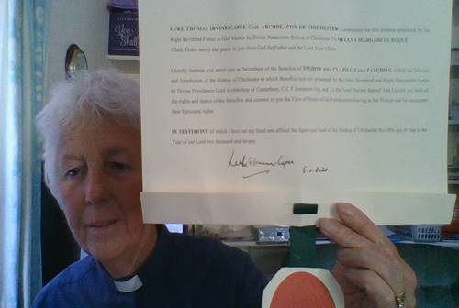

We are getting used to living with restrictions regarding keeping socially distant and as we missed the Friends’ Spring Walk I thought it might be cheery to look at a photograph of bluebells.

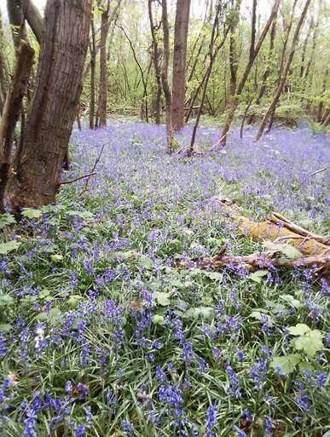

Patching has a mystery good Samaritan. I have been unable to find our who it is but someone has cut back the overgrown beech hedge at the church.
I have never seen the hedge looking so good. Thank you very much.

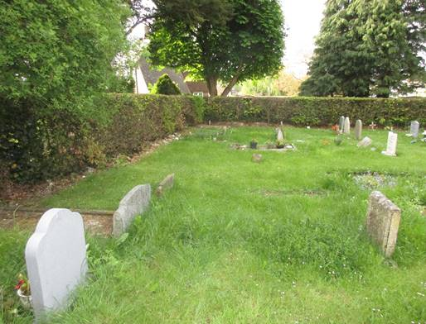

From an unsolved to a solved mystery. One morning this week I noticed that the edges of the compost heap at Robinswood looked as though they had been trampled by quite a large animal.
Could it be one of the creatures that regularly visit the garden, dog, fox, cat, pheasant, large pigeon?
That afternoon on the way to the compost heap I saw a creature scraping the ground in that area. It was a tiny mole. It stayed while I dashed off for a camera and here is the photo of the mole.
It was put to me that the thing most gardeners would think of going to get, on seeing a mole, was not a camera. It eventually scurried towards the garden fence. (Apologies to near neighbours).

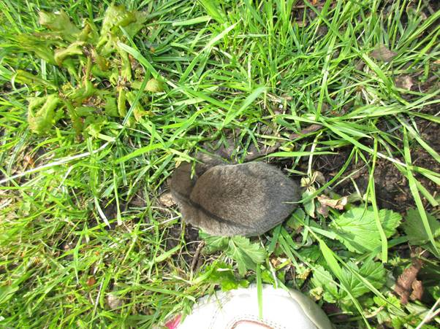

Stay safe everyone
Gail and Kath

